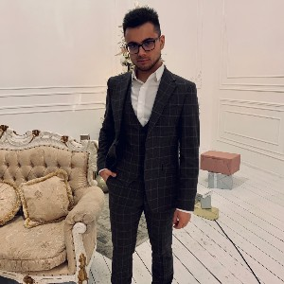Farid Mahmudov

Web-master

 [FMahmudov1997@mail.ru](mailto:FMahmudov1997@mail.ru) +375298379785

 Minsk, Belarus  [t.me/…](https://t.me/Farid_Mahmudov)

# Краткая информация

From the moment I graduated from the University, I tried myself in many spheres from a bank employee to an Apple technology specialist. There were victories and defeats, but the main thing is a good lesson and experience in life.

# Проф. навыки

Basic Javascript, Jquery and Python

Git and GitHub Wordpress development

HTML 5 CSS 3 Sass / Scss

Basic Gulp Adapted layout

## weblancer.net

Web-master 07/2021 - наст. время

## i-Store (Apple Premium Reseller)

Worked as Account Manager / Technician specialist

12/2019 - 11/2021

**Bank BelVEB, OJSC** technical specialist 09/2019 - 11/2019

**BPS-Sberbank, OJSC** Client manager 03/2019 - 07/2019

# Опыт работы

Website layout, filling with content, adaptation for different devices

Sale and full post-sale service of Apple appliances in the retail business segment Interaction with clients, consultations, support, hot calls.

Work in 1c, CRM (it4profit), preparation of various documents (specifications) when servicing legal entities. Technical customer support - acceptance for warranty service, repairs and operations carried out with software.

Selling a wide range of banking services, communicating with clients, solving technical problems, working out objections, working with various programs.

work in the segment of small and micro business

consulting on financial products (loans, deposits, leasing, acquiring); salary projects. Cold and hot calls - a working base and attraction. Work with document flow, sale of banking services.

# Образование

**ITAcademy** Front-end-Developing HTML CSS Javascript 2021 - 2022

## International University "MITSO"

2014 - 2018

Faculty of Law - International Law

2021

# Сертификаты

О себе

**Предпочтения в работе** Graduated from the University in 2018, Faculty of Law (International Law) with a specialization of International Commercial Law. The years during the university were interesting and rich - I received a good store of knowledge. After university, I tried myself in many areas - there were as i said before ups and downs. A great desire to develop, earn, and improve myself.

I have extensive experience in sales and speak English.

At the moment, for a year already, i ve been seriously passionate about IT technologies in the field of front-end web development and everything related to this industry - I would also like to join this environment to gain experience even as an intern. I already have confident knowledge of CSS SCSS Sass HTML (responsive layout) + Javascript Jquery base. I know a little PHP, I can work with git

I also understand the development of a website on Wordpress

I am full of desire to learn and achieve heights in this direction. here is the link of my website: https://egoist66.github.io/FaridMahmudov-pages/index.html